PatentMiner: Mining Knowledge from Patent Data

Jie Tang (Associate Prof.) and Minlie Huang (Assistant Prof.)
Department of Computer Science and Technology, Tsinghua University
2010-9-6

Executive Summary
A patent is not only an intellectual property granted to the inventor, but also an important source of information to understand the evolution of technologies and business plans. In this project, we aim to conduct systematic analysis of the evolution of technology trends from patent data. The work will be based on the results of our previous year's collaboration on topical trend analysis. We have already developed a system, PatentMiner, which provides services such as patent search, topical analysis, and patent summarization. In the next year, we plan to focus on four research topics: patent recommendation, patent ranking, hierarchical topic modeling, and competitor analysis. We will investigate new approaches on these four research topics and target top conferences and journals for publication. In addition, we will enhance the system performance of PatentMiner to further demonstrate the effectiveness and efficiency of the proposed approaches.

Research Goal
Patent data has become one of the most important information sources to analyze trends of emerging technologies. On the internet, there is a huge volume of patent data. For example, the US patent database contains more than 3 million patents, and Google’s patent search collects data from more than 7 million patents. However, people looking for useful information from these patents have an uphill battle. For instance, by querying “oil or gas” in Google patents, we obtain more than 100,000 patents. To quickly digest such a large number of information sources is always a challenging problem.
In the past year, we have made accomplishments on deep understanding of patent documents using natural language processing and data mining techniques. The applications include patent classification, key components extraction, patent similarity measurement, query-specific multi-patent summarization, concept clustering, topic trend and evolution modeling, and competitor analysis. As relevant to what are proposed here, we have developed information distance based and graph based summarization approaches, structure-aware summarization, and topic models for trends and evolution analysis. We have developed a system called PatentMiner that provides various services to analyze the patent data such as Patent Ranking, Competitor Analysis, Topic Modeling, and Summarization. However, to deeply understand the fundamentally evolutionary patterns of technologies from the pattern data, many challenging questions are still open. Here are a few examples. Given the retrieved patents for a query, how many subtopics are there? How to quickly identify the key patents for each subtopic? How to improve the patent ranking performance by incorporating user feedbacks? Given a company, how to identify its competitors and further how to unveil the evolutionary pattern of the competitors?

Review of Existing Work and Challenges
- Existing Work
In the past year, we have made accomplishments on deep understanding of patent documents and topical trend analysis using natural language processing and data mining techniques. On deep understanding of patent documents, we investigate some problems including patent classification, key components extraction, patent similarity measurement, query-specific multi-patent summarization and concepts clustering. As relevant to what are proposed here, we have developed information distance based and graph based summarization approaches, and structure-aware summarization. Based on LDA, we proposed a topic model to do sentiment classification for review mining.
On topical trend analysis, we employ the ACT model to find a latent topic space to bridge the heterogeneous objects: patents, companies, and inventors. Based on the discovered topic models, we have developed the expertise search (retrieve expertise patents, companies, and inventors for a given query), competitor analysis (find competitors of a company), topic-based trend analysis.
Last year, we published some text mining relevant papers on ACL, KDD, COLING, NAACL, and AAAI. In addition to the above work, we have been working on natural language processing and data mining for a long time, and the following summarizes our previous work from three aspects: natural language processing, search and data mining, and system.
Natural Language Processing: We have many studies on natural language processing such as semantic entity recognition and semantic relationship extraction, where these methods obtained the best results at the official evaluation of BioCreative 2006. On information extraction, we propose a series of approaches to address different challenges. For example, we propose a rule-similarity based extraction method: iASA; a classification based cascaded extraction method; a Tree-structured based Conditional random fields for information extraction. We also investigate the text cleaning problem and propose a unified approach for text normalization. We have proposed two summarization methods: one is based on random walk graphs; the other is based on information distance. The proposed summarization methods achieved the top three results during the international competition of TAC 2008/2009 organized by NIST. We also studied the topic-based summarization problem. Related papers are published at KDD, ACL, IJCAI, SDM, CIKM, ISWC, COLING, EMNLP, JoDS, Bioinformatics, etc.
Search and Data mining: On latent topic models, we proposed a LDA-based topic model to extract biology experimental methods from full-text articles, and perform multi-label document classification. We have proposed an Opinion PageRank algorithm based on random walk graphs, to answer opinion questions such as “why do people like iphone”. We presented a 2-D conditional random field model to find the answer to the question posted in forums. We invented a method of constructing evolution trees. We have done much work on opinion and review mining such as selecting the most typical or comprehensive reviews for travel advising. On probabilistic (topic) models, we propose ACT model which can model topics over heterogeneous data in a unified way. We also propose methods for expert finding, academic search, and name disambiguation. We also consider the influence problem and propose a topical factor graph model to formalize the influence problem. On data integration, we have been focused on ontology matching and propose a dynamic matching framework, called RiMOM. A prototype system has been developed based on the framework. We participated the international contest on ontology matching, OAEI, and achieve the first place on several matching tasks. On event detection, we propose a clustering based method for event detection and event tracing. Related papers are published at SIGKDD, SIGMOD, SIGIR, ICDM, CIKM, ACL, TKDE, JWS, etc.
Systems: We developed PatentMiner.org (http://patent.tminer.org) for patent search. We have already collected more than 1,500,000 patents, 200,000 companies, 1,200,000 inventors, and more than 3,000,000 patent-patent citation relationships. Services such as expertise search, topic browser, competitor, and summarization have been provided. We also have developed and published systems including ONBIRES, a biology knowledge management and extraction platform (a domain-specific information extraction system); Quanta, a question answering system which returns exact answers in response to a natural language question; ProCaR, a review mining system for product comparison and recommendation.
- Related Work
Though document archive and social data are accumulating in a growing speed, the quality of such data varies from very high quality to very low (e.g. spammers). For example, most scientific publications only have marginal contribution to the community, while only a few of them have high influence. In many social network websites, most user-generated contents are not influential (or not of high quality) to others. To facilitate recommending important contents from a large number of documents, it’s important to identify those documents of high quality or high influence. Here are some typical questions we may ask:
- Which papers should be recommended on some specific topics (e.g., data mining, natural language processing)?
- Which patents are most important for a user query with respect to industry impact?
- Which parts of a document is most important? Such as finding the important passages in a document, or finding most important claims in a patent.
Evaluating the quality of information has been a hot topic in many social media analysis problems, such as answer quality and review quality assessment (Agichtein et al., 2008; Lu et al., 2010). To compute the influence or quality of information (sometimes it’s known as information trust), several lines of research have been proposed: (1) reputation-based systems determine an entity’s trust or standing among peers via transitive recommendations, as PageRank (Brin and Page, 1998) and HITS (finding Hubs and Authorities) (Kleinberg, 1999); (2) Information-based approaches utilize content (rather than peer recommendations) to compute trust, and are often specialized for a particular domain. For example, (Zeng et al., 2006) and Wikitrust (Adler and de Alfaro, 2007) determine trust in a wiki’s text passages from sequences of revisions.
For competitor discovery, there are a few researches trying to discovering competitors for a company. For example, Bao et al. propose an algorithm called CoMiner for competitor mining which can discover competitors, competing domains, and competitors' strength for a specific company (Bao et al., 2008). A novel algorithm called CoMiner is proposed, which tries to conduct a Web-scale mining in a domain independent manner. The CoMiner algorithm consists of three parts: 1) given an input entity, extracting a set of comparative candidates and then ranking them according to comparability, 2) extracting the domains in which the given entity and its competitors play against each other, and 3) identifying and summarizing the competitive evidence that details the competitors' strength. Another related work is (Li et al., 2006). Liu et al. argue only finding information that matches the user's specifications is insufficient for Web information discovery (Liu et al., 2001). In many applications, finding information that the user has no idea of is also of great importance. For example, it is useful for a company to find unexpected information about its competitors, e.g., unexpected services and products that its competitors offer. With this information, the company can learn from its competitors and/or design counter measures to improve its competitiveness. Since the number of pages of a typical commercial site is very large and there are also many relevant sites (competitors), it is very difficult for a human user to view each page to discover the unexpected information. Automated assistance is needed. Finally, they propose a number of methods to help the user find various types of unexpected information from his/her competitors' Web sites. Chen et al. present a framework for user-oriented text mining. It is then illustrated with an example of discovering knowledge from competitors' websites (Chen et al., 2005). The knowledge to be discovered is in the form of association rules which are a simple and useful form of knowledge that can be efficiently discovered from large volume of documents. They observe that though pruning based on objective measures is effective, it fails to take into account the user's background knowledge. Using subjective measures requires the user to provide what they expect or do not expect, which is hard to define before the mining process. They have presented a novel approach, in which the user's background knowledge is modeled as a concept hierarchy, and the novelty of the extracted rules are measured by the semantic distance between words in the hierarchy.
On topic model and topic evaluation analysis, Blei and Lafferty propose a dynamic topic model for analyzing the time evolution of topics (Blei and Lafferty, 2006). By putting Gaussian noise on the natural parameters of the multinomial distributions, the topics will evolve smoothly between time slices. This work only deals with the discrete time slices, further Wang et al. propose a new model called the continuous time dynamic topic model (Wang et al., 2008). By using the Brownian motion for modeling the latent topics in the document collections, they develop the sparse variational inference which can fast compare models. Leskovec et al. propose a probabilistic framework for tracking short, distinctive phrases by clustering phrases (Leskovec et al., 2009). They can identify a broad class of memes that exhibit wide spread and rich variation on a daily basis. Mirowski and LeCun propose a method for training Dynamic Factor Graphs(DFG) with continuous latent state variables which can be seen as the Generalized Expectation-Maximization (Mirowski and Lecun, 2009). By using smoothing regularizer or sparsity penalty on the parameters, DFG can generate nontrivial solutions for high-dimensional latent variables.
There are also some similar but quite different commercial systems such as starlight (http://starlight.pnl.gov/) and IN-SPIRE (http://in-spire.pnl.gov/). These two systems are essentially information visualization softwares. Starlight couples information modeling and management functionality with a visualization-oriented user interface. The system has a focus on visualization instead of content modeling (most of such functions is based on co-occurrence). As there is no free trial for this system, it’s impossible to fully explore the functionalities and features of it. As for IN-SPIRE, the software has the following functions (as demonstrated on its website): creating a visualization from a Google search, from text document, from Microsoft outlook, from PubMed, or using RSS feeds. It can also explore temporal patterns, and data relationships with themes and facets. Again, this system is much more focused on visualization. Two major differences between the two systems and ours are that: 1) their functions require a lot of interactions from users, and users must be well-trained to be able to use the tools; 2) there is very limited function for deep semantic and association analysis. In contrast, our work is more focused on automatic topic analysis and modeling for heterogeneous data: we are not only modeling topics within a document, relationships between documents, but also modeling various networking data for competitor analysis, inventor analysis and so on.
- Key Challenges
The project of mining knowledge from patent data is non-trivial and poses a set of unique challenges:
- Given a query, how to improve the accuracy of expertise search on patents, i.e., how to improve the ranking performance of patents, companies, and inventors?
- How to allow the users to quickly understand the retrieved information?
- How to generate a hierarchical knowledge structure from the patent data to allow the user to have an overview of all the patent information? Further how to incorporate the user interactions into the topic modeling process?
- How to model and discover the evolutionary pattern for competitors?
- References
- Eugene Agichtein, Carlos Castillo, Debora Donato. Finding High-Quality Content in Social Media. WSDM’08, February 11–12, 2008, Palo Alto, California, USA.
- S. Bao, R. Li, Y. Yu, and Y. Cao. Competitor mining with the web. IEEE Transactions on Knowledge and Data Engineering, 20(10):1297{1310, 2008.
- D. M. Blei and J. D. Lafferty. Dynamic topic models. In Proceedings of the 23rd international conference on Machine learning (ICML'06), pages 113-120, New York, NY, USA, 2006. ACM.
- X. Chen and Y.-f. B. Wu. Web mining from competitors' websites. In Proceedings of the eleventh ACM SIGKDD international conference on Knowledge discovery in data mining (KDD'05), pages 550-555, New York, NY, USA, 2005. ACM.
- J. Leskovec, L. Backstrom, and J.M. Kleinberg. Meme-tracking and the dynamics of the news cycle. In Proc. KDD, 2009, pp.497-506.
- R. Li, S. Bao, J. Wang, Y. Yu, and Y. Cao. Cominer: An effective algorithm for mining competitors from the web. In Proceedings of the Sixth International Conference on Data Mining (ICDM'06), pages 948-952, Washington, DC, USA, 2006. IEEE Computer Society.
- B. Liu, Y. Ma, and P. S. Yu. Discovering unexpected information from your competitors' web sites. In Proceedings of the seventh ACM SIGKDD international conference on Knowledge discovery and data mining (KDD'01), pages 144{153, New York, NY, USA, 2001. ACM.
- Yue Lu, Panayiotis Tsaparas, Alexandros Ntoulas, Livia Polanyi. Exploiting Social Context for Review Quality Prediction WWW 2010, April 26–30, 2010, Raleigh, North Carolina, USA.
- Brin, S and L Page. 1998. The anatomy of a large-scale hypertextualWeb search engine. Computer Networks and ISDN Systems, 30(1-7):107–117.
- Kleinberg, J M. 1999. Authoritative sources in a hyperlinked environment. Journal of the ACM, 46(5):604–632.
- Adler, B T and L de Alfaro. 2007. A content-driven reputation system for the Wikipedia. WWW ’07, 7:261–270.
- P. Mirowski and Y. Lecun. Dynamic factor graphs for time series modeling. In Proceedings of the European Conference on Machine Learning and Knowledge Discovery in Databases (ECML/PKDD'09), pages 128-143, Berlin, Heidelberg, 2009. Springer-Verlag.
- C. Wang, D. M. Blei, and D. Heckerman. Continuous time dynamic topic models. In Proceedings of the 24th Conference in Uncertainty in Arti¯cial Intelligence (UAI'08), pages 579-586, 2008.
- Zeng, H, M Alhossaini, L Ding, R Fikes, and D L McGuinness. 2006. Computing trust from revision history. Intl. Conf. on Privacy, Security and Trust.

Description of Proposed Methodology
We aim to conduct a thorough and systematical investigation on knowledge mining from the patent data. The framework of this research project is shown in Figure 1. Primarily we will focus on the following four components: Influential patent identification, Topic hierarchy generation, Improving ranking performance, and competitor analysis.
1. Identifying High-quality/influential Content
The quality of information is factored by several aspects: the reputation or authority of the author who published the content; the quality of the content (such as readability, grammaticality, relevance) particularly for user-generated content on the Web; the peer reviews toward the content. These heterogeneous data sources play important roles in determining the quality or influence of the content. However, it is quite challenging to integrate these sources together due to data availability and the scale of the data. In this proposal, though we do not limit to using only single type of data, we have a focus on determining the quality by content.
We will propose to use unsupervised and supervised algorithms to address this challenging problem. A natural option for unsupervised modeling is using topic modeling to find high-quality contents based on relevance. Obviously quality evaluation should be topic-specific (or, query-specific). Given a set of documents (news articles, patents, etc.), we will first discover a set of topics from the archive. Then, we will estimate a probability distribution for these topics using language models or topic models. To respect domain knowledge, we may use a dictionary about the oil & gas industry which contains around 11000 concepts and some shallow structures of the concepts. This dictionary would help us identify important domain concepts for finding high quality or influential content. Once we have such a distribution, we can further compute the probability of a document d belonging to a topic z, i.e., Pr(z|d). For each topic, we have a set of documents with highest Pr(z|d), say C(z).
With some annotated corpus which comes from ExxonMobil experts, the quality of each document in the collection will be computed using supervised machine learning algorithms. We can approach the task as a classification problem or regression problem. These algorithms will be based on multiple features that favor quality measures: perplexity features (measuring dissimilarity), clustering features (similarity to the centroid of topic z), and external features from other information sources (such as citations, social context).
Also, we may consider this problem in a more general context. Since identifying high-quality content mostly happens in network scenarios, we will study how to employ more sophisticated features such as user profiles, user social networks, and user-user interactions.
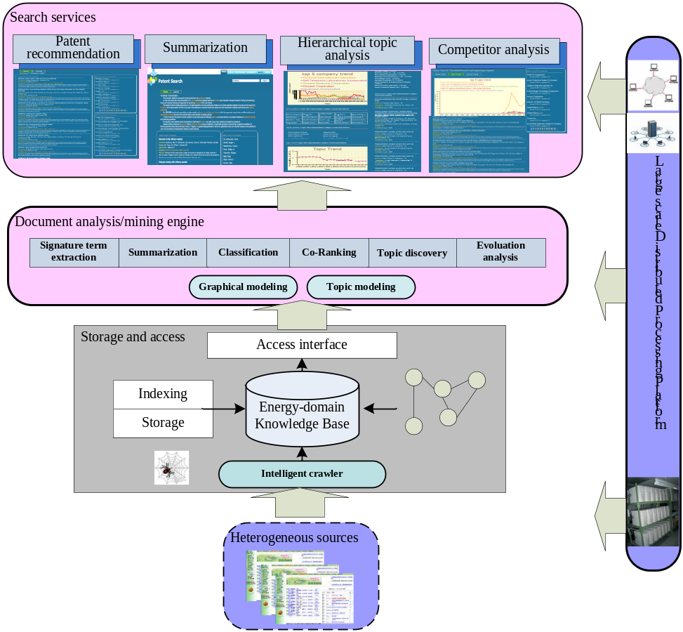
Figure 1. Framework of PatentMiner

2. Generating Topic Hierarchy and Structure-aware Summaries
Hierarchical Topic Model (Blei et al., 2004) and Chinese restaurant process have been used to discover the relationship between words, and organize them into a hierarchical structure. Our motivation is that only discovering the concepts or the concept clusters is not enough, since users may not know the relationships among them. We need to explain to the users how those concept clusters are connected to each other, what are their relations, and how the concepts are organized.
However, the study on hierarchical topic model is still quite limited. For example, this model can only find relations between unigrams (single words); the model is unsupervised but in reality we sometimes already have or partially have the hierarchical prior.
Thus, in this proposal, we are going to use hierarchical topic model to find a topic hierarchy and to propose semi-supervised or supervised methods based on this LDA model. Another way to generate topic hierarchy is to use context similarity. Given a concept (such as a bigram), we can combine all the context of different occurrences into a vector. Then the hierarchy can be built on such vectors based on Hoeffding’s Inequality (Hoeffding, 1963). Once again, to assess the quality of generated hierarchy, we need domain terminologies which may come from a dictionary about the oil & gas industry.
Once we have such a hierarchical structure, another interesting problem is how to generate dynamic summaries along the structure. As top-level concepts in the structure are more abstract in meaning, and bottom-level concepts are more specific, the generated summaries at different levels should have different focus on. Our proposal is to use the structure as a prior to score textual units dynamically, where textual units can be sentence, passage, or claim in patent. A related problem is to generate structured summaries (hierarchy is a specialized structure): given a query, produce a summary for it, covering as much diverse aspects as possible. The latent structure, though we may not know it in advance, can be discovered using our subtopic mining algorithm developed in the first year. Then, the problem is decomposed into two sub-problems: textual unit ranking and selecting (the two problems can be jointly solved sometimes). Ranking is to determine the relevance of a textual unit to a prior topic while selecting will choose a set of units to satisfy the information need defined by the task.
3. Improving Ranking Performance
The task is to apply the learned models to search the different types of objects (companies, patents, and inventors) simultaneously. Also, we already tried to combine the topic model with random walk in our current research. In Phase II of the project, we will further extend the random walk in homogeneous network of document (patents cite patents) to heterogeneous networks of companies, patents, and inventors. The goal is to investigate how to integrate the proposed topic model into the random walk framework for improving the search quality. It is non-trivial to perform these tasks. First, as the patent network contains different types of objects (e.g., patents, authors, and companies), it is not immediately clear how to integrate the different objects into a unified probabilistic model. Second, it is unclear how to effectively combine the textual topic model with random walk based on networking information, e.g., how to define the transition probability between different types of objects based on the learned topic models.
Based on the ACT models, we can obtain a form of document modeling using an equation by integrating out the topic distribution. However, the learned topics by the topic model are usually general and not specific to a given query. Therefore, only using ACT itself for modeling is too coarse for patent search. Our preliminary experiments also show that employing only the ACT or LDA models to information retrieval hurts the retrieval performance. In general, we would like to have a balance between generality and specificity. Thus, we will define some method for combining the ACT model and the word-based language model.
In addition, usually user feedbacks can reflect their personal judgment of the relevance between patent and a specific query. So the user feedbacks in click through data logged by the website can be exploited for refining the patent ranking results. In general, the method will consist of two stages. For the first stage, we can use the method in section 4 for obtaining the ranking score f(q; x) of patent x for a given query q; for the second stage, we will introduce how to learn a ranking function from the user feedbacks in this section. We will employ Ranking SVM which is a state-of-the-art ranking learning algorithm.
4. Competitor Analysis
The proposed model is called Author-Company-Topic (ACT) model. Essentially, the model utilizes the topic distribution to represent the inter-dependencies among authors, patents, and companies. In our ACT model, each author is associated with a multinomial distribution over topics and each word token in a patent and the company stamp is generated from a sampled topic from the multinomial.
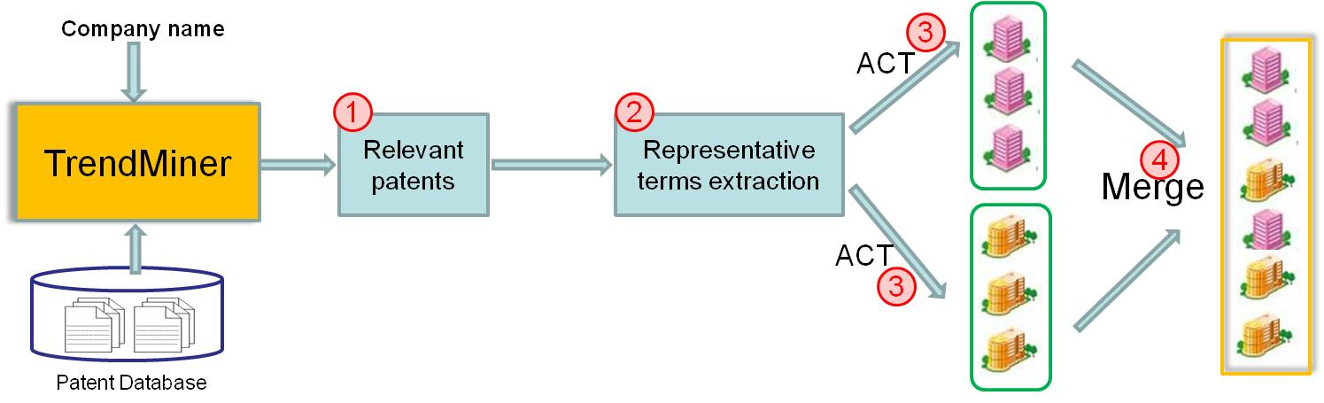
Figure 3. Processing flow of competitor analysis

ACT model captures the relationships between inventors, companies and patents by the latent topics at a static time slice. As we know, the latent topics discovered from the patents evolve over time. In order to capture the dependences between the ACT models at different time slices, we propose another novel model called Temporal ACT(TACT) Model. In TACT model, we add smooth constraints on the prior parameters of ACT models by regularization terms to ensure that the topics evolve over time smoothly. The time dependences between prior parameters of ACT models at different time slices make the latent topics of TACT model evolve smoothly.
Specifically, we will first find the representative terms from the company-related patents, and use them to find the relevant companies based on ACT model, finally merge the found company list for the final company output. Figure 2 shows the procedure of our proposed method. In particular, there are four steps: (1) Finding the company relevant patents. In this step, for a given company, we first retrieve the relevant patents by PatentMiner system from our patent database. These patents are all published by this given company. (2) Extracting representative terms. In this step, we try to extract representative terms from the retrieved patent collection in the first step. By representative term, we mean the key terms which can capture the main topics of this company. There are two steps for this: first, we use sentence chunking for extracting popular phrases; second, based on the probabilities of each word belonging to a topic by ACT model, we can calculate the probabilities of each phrase belonging to a topic by which we can find the representative phrases for this company. (3) Generating the competitor candidates. After obtaining the representative terms for a company from its patent data, we can use them as queries for patent ranking, by which we can get different competitor candidate list for the representative terms. (4) Ranking the competitors. In this step, we try to rank all the competitor candidates for generating the final list for the given company. The main idea is summing up all the company-related scores as its final score by which all the candidates are ranked.
To provide the users with insights into the micro-level of the competitive information, we aim to further extend the competitor discovery at the topic level and also consider the time-dependent evolution of the competitive patterns. We will propose a novel approach referred to as TopCom. More specifically, we plan to present a temporal probabilistic model to model the evolutionary patterns of inventors, patents, and companies simultaneously. Based on the modeling results, we provide various competitive analysis, including topic-level competitor discovery, competitor evolution analysis, and competitor prediction. At a high level, the approach primarily consists of the following steps:
1) We plan to present a unified probabilistic model to discover evolutionary topic models of companies, inventors, and patents. This is the basis of the following steps.
2) We will propose several ranking methods to perform various competitor analysis, including global competitor discovery, topic-level competitor discovery, and competitor evolution analysis.
3) We will present a method to identify (predict) potential future competitors. The purpose of the first step is to simultaneously model the evolutionary patterns of companies, inventors, and patent contents. This could be done by separately modeling patent contents, inventors, and companies. However, such an approach cannot leverage dependencies between the heterogeneous objects, and also cannot capture the time information. Our basic idea is to first partition the patent data into different time windows. Patents in each time window are described using a generative process. Topic models discovered from patents in the previous time window are used as the prior to guide the modeling process of patents in the next time window. In this way, the model combines the modeling of different objects over time in a unified framework. Based on the modeling results, in the second step, we design several ranking methods to perform various competitor analysis and in the last step, we present a method to predict potential future competitors.
5. New GUI Design
We will design a totally new graphical user interface for the PatentMiner system. We will try to make the user's interaction as simple and efficient as possible.

Deliverables and Timelines
Kick-off preparation
Period: September 1, 2010 – October 6, 2010
Description: Define the research plan, review state-of-the-art technology, and prepare dataset.
Key deliverables:
- A detailed research plan for the project.
- A landscape review of commercial and academic applications
- A survey of state-of-the-art patent mining programs (i.e., http://starlight.pnl.gov/, http://in-spire.pnl.gov/)

Methodology Development Phase I
Period: October 7, 2010 – Jan. 31, 2010
Milestone: Release of beta version 1.0 of PatentMiner
Description: The focus of this phase is to incorporate domain knowledge to refine PatentMiner and to release the Beta version of PatentMiner to EMRE. More specifically, we will develop better means to incorporate domain knowledge to improve the performance of topic modeling performance, competitor ranking, inventor ranking, patent influence analysis, and patent summary. We will work with EMRE researchers closely to evaluate the performance the refined methods and to prepare the annotation data sets. Tsinghua team will develop a feedback function on the system so that EMRE researchers can easily provide comments and feedbacks online. The NLP research work, which was tested on a small dataset, will be tested on the same data set that PatentMiner is running on and will be merged into PatentMiner. In the meanwhile, the GUI of PatentMiner will be redesigned and the new GUI will be available in the next phase of research.
Key deliverables:
- Methodology on measuring patent influence and relevancy.
- Methodology on incorporating domain knowledge to refine patent ranking, inventor ranking, competitor analysis, and topic discovery.
- PatentMiner beta version 1.0 for a small number (i.e., around 10) of ExxonMobil users.
- Papers submitted to ACL/SIGIR/IJCAI/SDM/KDD (most deadlines are due in January).
- New GUI design to be implemented in the next phase of research.

Chinese Traditional Spring Festival
February 1. – February 28.

Methodology Development Phase II
Period: March 1, 2011 – July. 31, 2011
Description: The focus of this phase is to develop new methods to improve the performance of topic modeling and patent summarization. More specifically, we will develop hierarchical topic modeling and structured summarization.
Key deliverables:
- Do research and experiments on hierarchical topic modeling and structured summarization.
- Monthly telecon to review status and communicate user experiences with PatentMiner.
- Prepare PatentMiner beta version 2.0 for expanded number of ExxonMobil users.
- Prepare a paper for submission to CIKM/ICDM/NAACL/EMNLP/WSDM.

Student Summer Visiting
August 1. - August 31.

Methodology and Prototype Refinement
Period: September 1, 2011 – Dec. 31, 2011
Description: System improvement and knowledge transfer.
Key deliverables:
- PatentMiner version 1.0
- System implementation, debugging and improvement.
- Final report and knowledge transfer.

Budget and Planning
Category | Description | Amount
Overhead |  | $27,000
Travel | - Two Professor trips to EMRE CSR  - Two Student trips to EMRE CSR  - Conferences | $25,000
Compensation | Compensation for non-PI researchers | $30,000
Supplies | Office space, water, power, computers | $5,000
Miscellaneous |  | $3,000
Total |  | $90,000

Personnel
Jie Tang
Dr. Jie Tang is an associate professor in Department of Computer Science and Technology of Tsinghua University. He obtained his Ph.D. degree in CS, Tsinghua University in 2006. He has been a visiting scholar at HKUST, Minnesota University, and Greece Technique University. His research interests include data mining, social Web mining, and Semantic Web. He proposes various information extraction methods, i.e., iASA: rule learning based annotation, classification based annotation, and TCRF: tree-structured CRF based annotation; and also a practical information integration tool RiMOM, which participated into OAEI contests from 2006 to 2008 and won the champion of many schema alignment sub-tasks. He obtained the award of the best employee of Department of Computer Science and Technology of Tsinghua University in 2007, the Best PhD Thesis Award of Tsinghua University, and was nominated as candidates for the 2006 Best PhD Thesis Award of China Computer Federation. He published more than sixty papers in international journals and conferences, including TKDE, JWS, JoDS and top conferences: SIGKDD, IJCAI, ACL, SIGMOD, ISWC, SDM, ICDM, CIKM, etc. He applied for seven patents. He has served/is serving as the Co-Chair of WWW-SWSM’08 Workshop, SWSM’09 Workshop, Financial Data Mining (FDM’2009) Workshop, Registration Chair of ASWC’06, Session Chair of WI’07, and PC member of more than forty international conferences, including top conferences like SIGIR and SDM. Additionally, he serves as the reviewer of a dozen of international journals such as TKDE, TKDD, Machine Learning, TALIP, PRL, SMC, JWE, KAIS, and JNLE. He has been invited to give talks at Microsoft Research Asia, Google China Research Lab, The Chinese University of Hong Kong, The Hong Kong University of Science and Technology, Institute of Computing Technology, Chinese Academy of Sciences, IBM TJ Watson, and University of Illinois at Urbana-Champaign.
He is the principle investigator of research projects funded by NSFC, National High-tech R&D Program (863), Chinese Young Faculty Research Funding, Minnesota/China Collaborative Research Program, IBM, Nokia, Sohu, etc. He is also involved as the major member of several projects such as National Foundational Science Research (973), NSFC, Greece-China collaborative project, Tsinghua-ITF collaborative project, and Tsinghua-Google collaborative project.
More information can be found at his homepage: http://keg.cs.tsinghua.edu.cn/persons/tj/.

Minlie Huang
Dr. Minlie Huang now is a faculty member of Dept. of Computer Science and Technology, Tsinghua University. He received his PhD degree in 2006. And his PhD thesis titled "semantic relation discovery and its application on bioscience text processing" was rated as "University Excellent Dissertation". During the first year stay in Tsinghua, He is awarded "Tsinghua Excellent Researcher Fellowship". He was a visiting scholar at NCBI, NIH, USA and at University of Hamburg.
His research interest includes machine learning, natural language processing, graph-based text mining, opinion and review mining, complex and interactive question answering. He has many experiences on natural language processing and text mining, including document summarization, the extraction of semantic relationships, text classification, document summarization, ontology-based information integration and bioinformatics applications. He led a group to participate in the update summarization track of Text Analysis Conference (TAC) 2008 and obtained competitive results. He leaded his group participating in the BioCreative 2006 Competition: the performance of Interaction Article Sub-task (classifying an article whether it contains at least one physical protein-protein interactions), Interaction Pair Sub-task (extracting physical protein-protein interactions), and Interaction Summery Sentence (generating a summary for an interaction) are all ranking at the top three places.
As a vice group leader, he played a key role in an 863 program (National High-tech Program in China), which is aiming to integrate and validate multiple data sources. He was the principle investigator of a project funded by Tsinghua Basic Research Foundation, which is titled "Knowledge discovery by integrating information from biological experimental data and literature data". He is the principle investigator of NSFC project titled "Graph based text mining theories and algorithms". He was the leader of MSRA joint project "comparative opinion mining", and Fujitsu Project “opinion search”. He developed system ProCaR and ONBIRES.
He has published papers on ACL, COLING, AAAI, NAACL, ICDM, PAKDD, and journals like Bioinformatics, Genome Biology etc. He served as PC member for ACL, EMNLP, Bioinformatics, and BMC Bioinformatics. More detailed resume at: http://www.csai.tsinghua.edu.cn/~hml/.

Other team members include: a faculty from Department of Art of Tsinghua University, two PhD students, one engineer, two masters, and two undergraduates.

